|  |  |
| --- | --- |
|  |  |
| We’ve Got: |  |
|  | **Keep Learning** serves as the **remote learning hub for students**. UCR's **online learning support site** for students, Keep Learning contains remote learning tips, goal setting, and time management resources, online assignment resources, instructional technology tutorials, resources on free software, loaner laptops, and Wi-Fi hotspotsto **help students keep connected to their academic experience.** |
|  | **Ask.ucr.edu** is a **vital** **referral hub for student services designed** to help students **navigate the complexities of campus** and provide quick connections to resources. AskUCR features **24/7 ScottyBot support** and **weekday live chat support** from UCR Libraries. AskUCR has **quick referrals to information** including: 1) registration, advising, and records, 2) health and housing, 3) student involvement, 4) library and learning support, resources, and videos, 5) managing costs and financial aid, 6) technology supports including laptop loans and free software for students, 7) common campus deadlines, and 8) campus support videos. |
|  | **Campus Collective** is a robust **peer mentoring network** that can **connect all incoming freshman and transfers with a volunteer Peer Mentor from UCR**. Creating a sense of community and helping freshman navigate campus, **peers will connect via text messaging**, without no need for a downloaded app. Using services from Mentor Collective®, who provides short mentor trainings, matching support, text message notes systems and resource referrals, conversation starters and nudges, and robust analytics. The Campus Collective will **leverage existing peer mentoring networks**, along with **volunteer mentors** to help first-time UCR students feel a connection to and sense of belonging with their peers and UCR. |

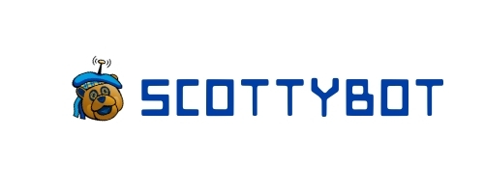  
**ScottyBot** is a **chat bot available to answer student questions 24 hours a day, 7 days a week**. ScottyBot contains a robust knowledge base of student information from **Financial Aid, Registrar, Undergraduate Education, Student Business Services, and Housing/Residential Life** as well as a small library of general campus knowledge. ScottyBot is powered by an artificial intelligence system that is always learning and ScottyBot is capable of **conversing in Chinese, Spanish, and English**.